Class preps O.C. teens for jobs

November 28th, 2011, 11:00 am · · posted by Mary Ann Milbourn
Teens looking for work not only don’t know how to get started, but if they manage to get an interview, many don’t know how to present themselves. Lori Kelman thinks she can help.
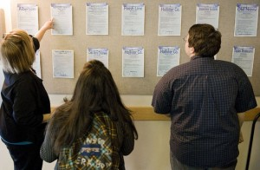
Kelman, a former KFWB radio reporter, is launching a class in Mission Viejo in January specifically aimed at 12 to 16 year olds to teach them communication skills for getting a job.
She notes that this younger generation has been raised on text messaging and has little understanding of how to speak to a would-be employer or the public.
“I’m going to give them self-confidence building tools and bolster their communication skills so they can comfortably present themselves in a professional setting,” she said.
Teens need all the help they can get in this market where they are competing against experienced adults for jobs. The unemployment rate in California for 16 to 19 year olds was 33.9% in October, down only slightly from 35.1% a year ago, according to the Employment Development Department.
Kelman’s eight-week class will teach public speaking, resume writing, interviewing and marketing. Students will also get exposed to broadcasting, public relations and media relations.
The class is being offered in partnership with the city of Mission Viejo. Kelman believes it is the first of its kind and could become a template for helping teens across the country.
She said she is targeting kids as young as 12 because while they may not be old enough for payroll positions, many of them can get their employment start in jobs like babysitting, lawn mowing or doing chores for an elderly neighbor.
The class will teach the young people how to approach adults in a professional manner and how to use the experience they get — whether it is in formal jobs or in volunteer work — to build a resume.

