[](http://cnn.com/)

Top of Form



[](http://schoolsofthought.blogs.cnn.com/)

http://i.cdn.turner.com/cnn/.element/img/3.0/1px.gif

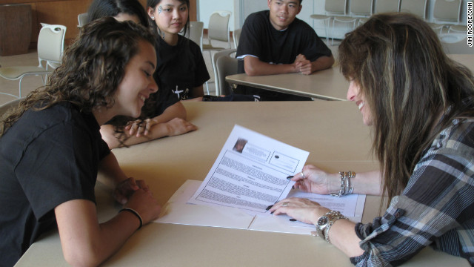

Lori Kelman (right) helps student Rebecca Smith and other teens improve fundamental communications skills lost to texting technology with her program, Enhancing Teen Communication.

April 24th, 2012

[**Texting teens learn to talk face to face**](http://schoolsofthought.blogs.cnn.com/2012/04/24/texting-teens-learn-to-talk-face-to-face/)

by **Jim Roope**, CNN

*Listen to CNN Radio's podcast from* ***Jim Roope*** *about a class that teaches teens to communicate face to face.*

**Los Angeles** **(CNN)** It's an often-observed teenage obsession: texting. Kids today spend an awful lot of time bent over cell phones sending text messages to each other. In fact, you can observe them sitting within normal talking distance from each other yet instead of talking, they'll be texting a conversation.

"I see that the kids are so involved in texting that they shy away from communicating face-to-face," said Lori Kelman, founder of the program 'Enhancing Teen Communication.'

"They bury themselves in text, hide behind texting, will say things through text that they wouldn't in a million years say to somebody face-to-face. That's not a good thing," Kelman said.

Kelman, who spent most of her professional life as a broadcaster for Los Angeles radio station KFWB and in corporate marketing and public relations, said she got the idea for the program when attending her daughter's class one day and as the kids would stand to introduce themselves and talk a little about themselves, many could barely string two words together. On child she said, stood there, hands folded, staring up for five minutes, not able to utter a word. "My heart broke for her," Kelman said.

This lack of fundamental communications skills, she believes, is a result of texting technology. It can hurt teens, she says, as they interview for jobs or college.

"We teach them resume writing, interviewing, public speaking, marketing, broadcast news writing, public relations and media relations," said Kelman. "They're going to have to communicate in the real world and that's part of the reason I developed the program is so that they could."

According to a recent study by the Pew Research Center, teens are twice as likely to communicate with their friends by text every day than calling them on the phone.

Ron Ye saw a flyer about Enhancing Teen Communication and brought his 17-year-old son Zack to check it out.

"You never really get a second chance to make a first impression," Ye said.

Zack Ye took the first eight-week session.

"Learning how to communicate with the world, learning how to get yourself out there and...for instance, applying for a job. She taught us how to do that," said Ye.

California's unemployment rate is still among the highest in the nation at just under 11-percent and in this state, the jobless rate for teens, 16-to-19-years-old, is 34-percent.

Kelman hopes the first 28 teens in her program should have an advantage when going out for job interviews. She has secured a copyright for her program and hopes to make it a business as the number of texting teens is growing.