Aliso Viejo
- Biz Directory
- Calendar
- Subscribe
- Become a Publisher Mom
National > Aliso Viejo Home > Parents Have Solution to Teen Texting Dilemma
Parents Have Solution to Teen Texting Dilemma

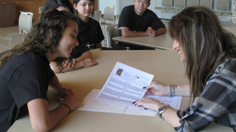

We spoke Pig Latin. Now it's LOL, BRB, and OMG. If your teen appears to have gotten away from the interpersonal communication we as parents consider to be life-critical, you'll be relieved to hear there's a new nationwide program for teens that gets them away from texting and back to face-to-face oral and written communication skills to help them prepare for employment. The program is called Enhancing Teen Communication™, and it originated in Mission Viejo. Founder Lori Kelman is a former Reporter for KFWB-AM in Los Angeles. Now she's using her communications expertise to teach resume writing, public speaking, interviewing, marketing, broadcasting, news writing, public relations, and media relations. Classes are taught in Mission Viejo once a week. To register call 470-3062.
You can also get the program online for your teen as a Student Training Manual, CD, or MP3 download at www.enhancingteencommunication.com.

Have your say

- Name:
- Email address:
- Comment:
- Captcha:
Type the two words:Type what you hear:Incorrect. Try again.
- <iframe src="http://api.recaptcha.net/noscript?k=6LcWhAkAAAAAAE4RrcCAKHLZuyvxsgfAdZ3Ki9zo" height="300" width="500" frameborder="0"></iframe><br /> <textarea name="recaptcha_challenge_field" rows="3" cols="40"></textarea> <input type='hidden' name='recaptcha_response_field' value='manual_challenge' />

Home / National / Privacy & Editorial policy / About us / Advertising / FAQ / Contact Us / Become a Publisher Mom! / Sign Up / Login
© 2012 Macaroni Kid, LLC

